SLOW ROASTED PORK BELLY WITH CHAR SIU STIR FRY

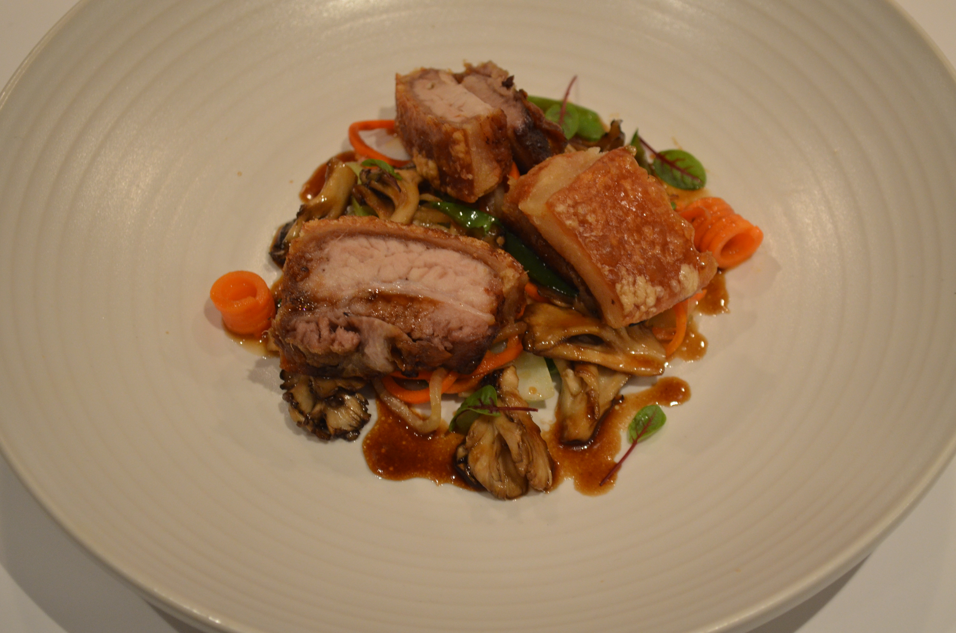

This seems like there is a lot going on, but it is so easy and so impressive. It tastes as good as it looks. The total time to make this is 3 hours, but most of that time is spent just waiting for the Pork Belly to roast. Here is all you need to make this incredible dinner:

Pork Belly

1 - 2 pound (1 Kg) piece pork belly (skin on) cut into 4 portions
2 Tbsp Olive Oil
1 Garlic Clove Minced
Salt
Char Siu Sauce

2 Tbsp Hoisin
2 Tbsp Dark Soy Sauce
2 Tbsp Honey
2 Pinches 5 Spice Powder
Stir Fry

1 Cup sliced mushrooms (shitake, maitake work best)
1 Cup coarsely chopped Bok Choy
1 Cup thinly julienne or spiralized Carrot
1 Cup thinly julienne or spiralized Daiko
Roast The Pork Belly

Mix Olive Oil and Garlic together
Rub the oil & garlic mix on the sides and bottom of the Pork, marinate in fridge for 4 to 8 hours
Heat oven to 400 Fahrenheit
Place a wire rack in a roasting pan
Arrange the pork portions on the rack skin side up with space between each portion
Rub a little Olive Oil on the skin
Generously Salt (this helps the skin get crispy)
Put the rack with the pork into the heated oven for 30 minutes
After 30 minutes, reduce heat to 300 Fahrenheit and roast for another 2 hours
Remove and let cool
(you can prepare to this point 1 or 2 days ahead of time)

Prepare the Char Siu

Mix all ingredients in a bowl and whisk
Add more or less 5 spice powder to your taste

Make Your Stir Fry

Heat a skillet or wok over medium high heat
Add a little Grapeseed or canola oil
When just starting to smoke add the bok choy and cook until starting to brown, remove from pan and set aside
Add the mushrooms to the hot pan and brown them
Add the Carrot and Daikon, cook for 1 minute then lower heat.
Add a little of the Char Siu sauce (to your taste, more isn't always better) and cook another minute or so
Add the Bok Choy back to the stir-fry and toss to coat with sauce

Assemble the Dish

Portion half of the stir-fry on each of 2 dinner plates
Slice the portions of pork in half, toss in the stir fry pan to coat with sauce and serve on top of the stir-fry

