**White Chocolate Mousse Tart – Pistachio Short Crust**

**Pistachio Crust**

140g all purpose flour

100g unsalted butter, room temperature

50g icing sugar

50g pistachios, chopped finely in food processor

Pinch salt

2 large egg yolks

4g baking powder

**White Chocolate Mousse Filling**

200g of white chocolate

2 gelatine leaves

250ml of double cream

2 eggs

1 pinch of sugar

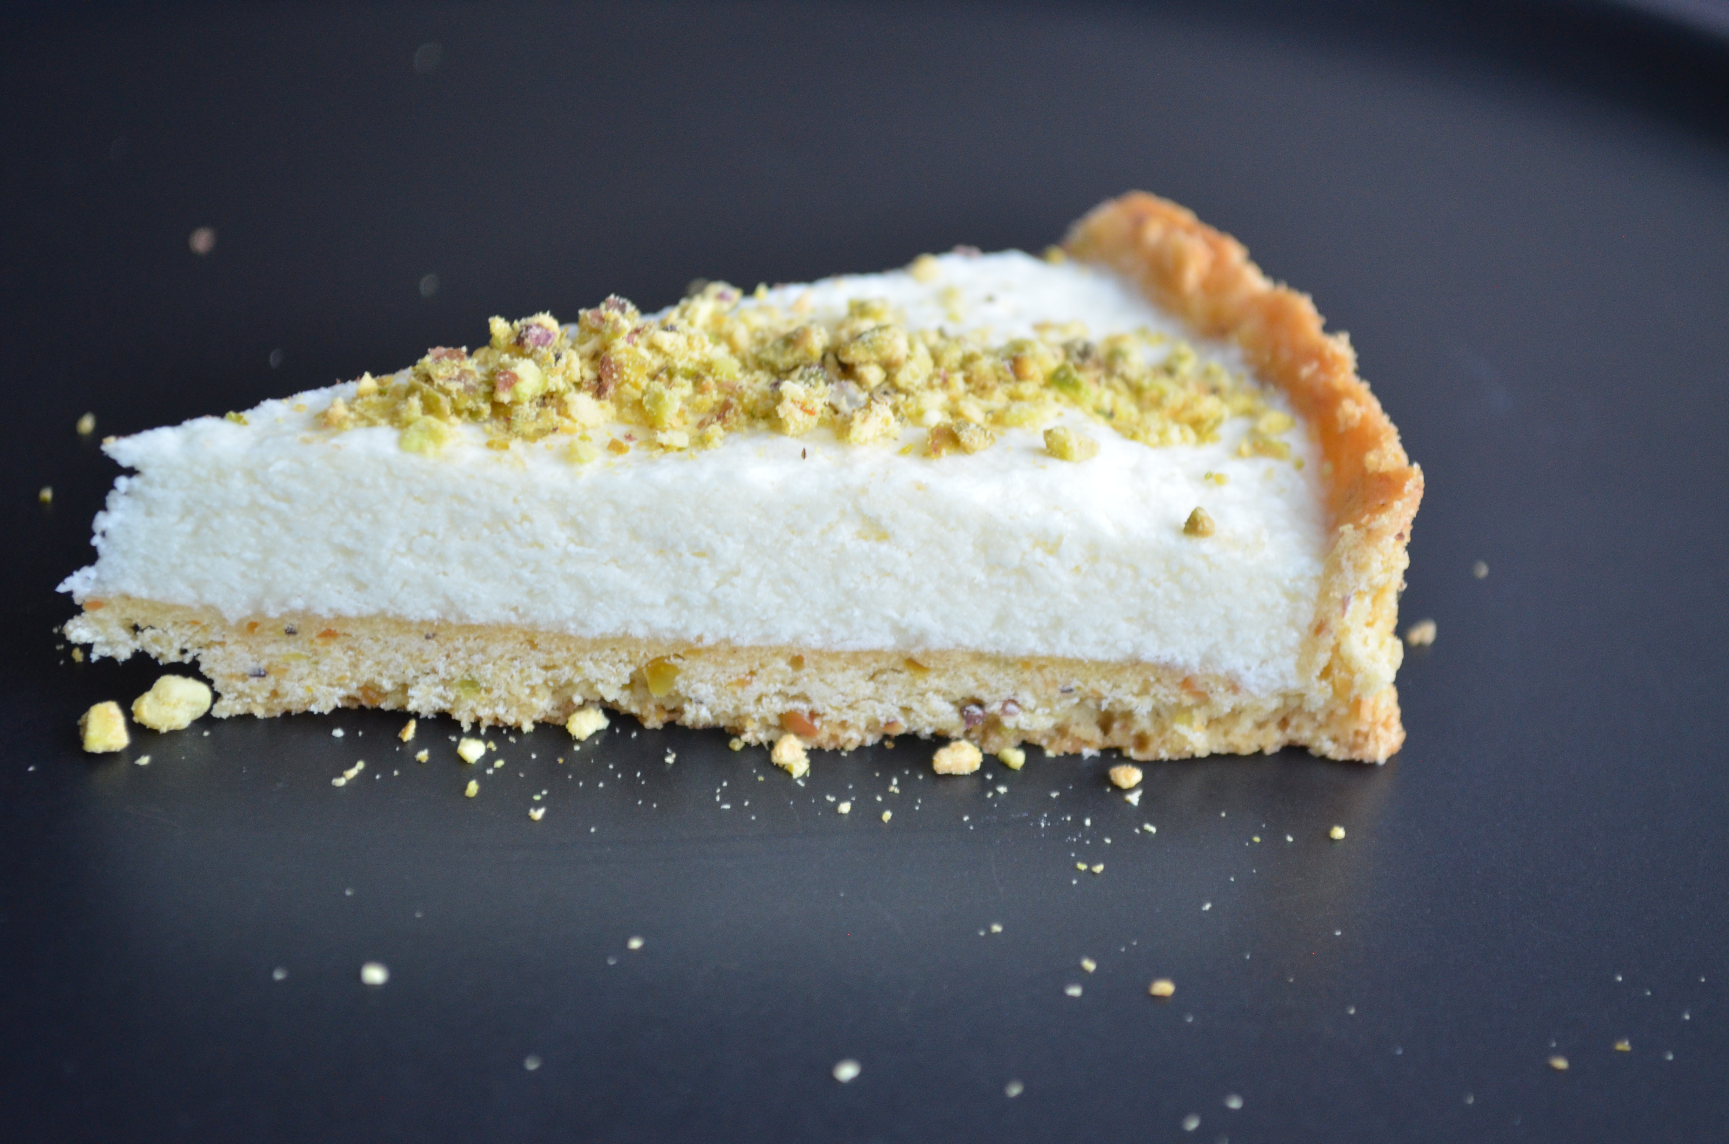

**Make The Crust**

1. Place the butter and icing sugar in the bowl of a stand mixer. Mix on low to combine
2. Add the chopped pistachio and salt, pulse to combine
3. Add the egg yolks, mix to combine
4. Whisk the baking powder into the flour to combine
5. Add the flour to the mixer
6. Mix on low until just combined
7. Wrap the dough in plastic wrap and refrigerate for at least 2 hours
8. When ready to bake the crust, preheat oven to 350
9. Roll the dough to about 3 – 4 millimetres thick
10. Place the dough over an 10 inch tart ring
11. Gently press into the tart ring, trim excess
12. Poke the dough to prevent excess rise
13. Bake in preheated oven for 12-15 minutes, until just starting to brown  
    (check half way, if the dough is puffing, poke more with a fork)
14. When just starting to brown, remove from oven and let cool completely

You can make the tart to this point 24 hours ahead

**Make the Mousse Filling**

1. Soak the Gelatin in ice water for at least 5 minutes to soften
2. Separate the eggs into two bowls
3. Lightly whip the cream in a bowl and set aside
4. Whisk the egg white to stiff peaks in a separate bowl
5. Melt the chocolate in a bowl over a pan of simmering water until smooth
6. Remove from heat
7. Whisk the egg yolks with the sugar and salt and add to the chocolate, work it in quickly
8. Squeeze water from the gelatin and whisk quickly in to the chocolate mixture
9. Quickly whisk in the whipped cream
10. Fold in the whipped egg whites until just combined
11. Pour the mousse into the baked tart shell
12. Refrigerate until set (about an hour)

Enjoy this mousse tart with additional chopped pistachios and a Raspberry Coulis or fresh Raspberries